
Joseph Banks Secondary College
Year 12 General Integrated Science
Task 10: Motion Test
ANSWERS

NAME: ____________________________________________________________________________

Date: Term 2 Week 5

Weighting: 7.5%

Time allowed for this paper:
Reading Time: 5 minutes
Working Time: 60 minutes

Motion Equations

v = d
t
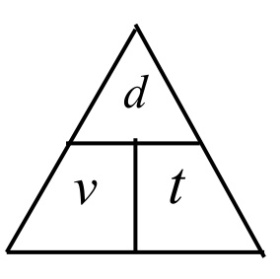

F = ma

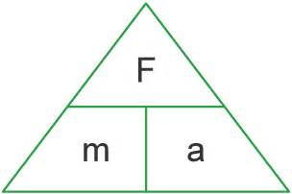

Structure of this paper
Section | Number of Questions | Marks Available
1: Multiple Choice | 15 | /15
2: Short Answer | 6 | /35
3: Extended  Response | 1 | /10
Total | 22 | /60 %

Section 1: Multiple Choice Questions [15 marks]
Read all answers and choose the BEST one. (1 mark each)
- Which two of the following variables is used to describe motion?
- speed and time
- time and momentum
- length and time
- mass and distance

- The speed limit in built up areas around Perth is 50 km.hr⁻¹ what would this be in metres per second is:
(a) 16.67 m.s⁻¹
(b) 13.89 m.s⁻¹
(c) 20.4 m.s⁻¹
(d) 25.3 m.s⁻¹

- What is a difference between an object's speed and velocity?
- Speed includes direction as well as the rate of travel.
- Velocity includes time during which travel occurred. 19 seconds.
- Velocity includes the direction of travel whereas speed does not.
- There is no difference.

- Which of the following statements correctly states Newton's first law of motion?
- Every object retains its state of rest or its state of accelerated straight-line motion unless acted upon by an unbalanced force.
- Every object retains its state of rest or its state of uniform straight-line motion unless acted upon by a balanced force.
- Every object retains its state of rest or its state of uniform straight-line motion unless acted upon by an unbalanced force.
- None of the above is correct.

- The acceleration of a car moving at a constant speed of 30 ms ^{–1} is
- 30 m.
- 30 ms ⁻¹.
- 15 ms ⁻².
- 0 ms⁻²

- The term inertia means which of the following? The tendency of an object to
- maintain its mass.
- remain in motion only.
- remain in rest or motion.
- stop the motion of other objects.

- According to Newton's second law of motion, acceleration is proportional to force. That means a larger force
- produces a smaller acceleration.
- doesn't affect acceleration.
- produces a smaller mass.
- produces a larger acceleration.

- John travels 2 km to the shop from home and remains there for 30 minutes. He does his food shop and decides to go home which takes him 10 minutes. What is his displacement by the end of the journey?
- 4 km.
- 2 km.
- 0 km.
- 6 km.

- You are standing in a moving bus, facing forward, and you suddenly fall forward. You can tell from this that the bus's
- velocity decreased.
- velocity increased.
- right.
- speed remained the same, but it's turning left.

The following two questions, 13 and 14 use the graphs below:
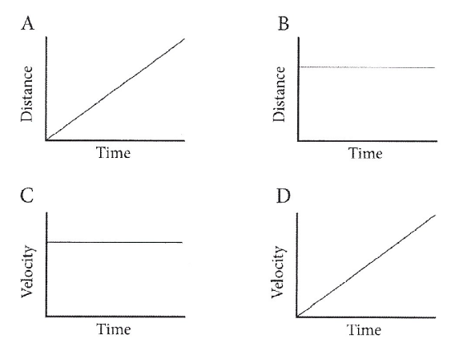
- Which of the following graphs shows a car accelerating?

- A
- B
- C
- D
- Which two graphs show a car travelling at a constant speed?

- C and B
- A and D
- A and C
- B and D

- What is the correct definition for stopping distance?
- The time it takes to stop.
- The addition of the reaction distance and the braking distance.
- The multiplication of the reaction distance and the braking distance.
- The reaction and braking times.

- In order for a moving object to slow down:
- Any force acting on the object would have to be removed.
- A frictional force is needed as it is the only one which will achieve this.
- Some net force has to be applied to the object in the opposite direction to the way it is moving.
- The force due to air resistance has to be increased.

- As a moving object slows down or looses speed, it would be correct to say that it has:
- Accelerated
- Decelerated
- A negative speed
- Travelled at a constant speed.

- A driver starts his car, accelerates to a speed of 60km/h, notices a 40 km/h school zone, slows to the correct speed and then regains a speed of 50 km/h which he maintains. Which graph best shows these changes?
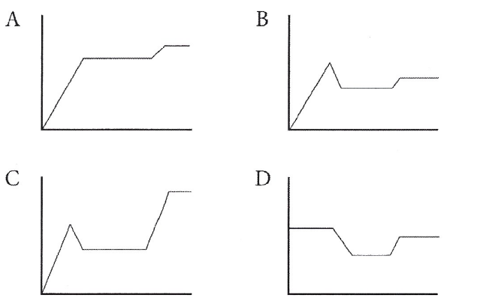
- A
- B
- C
- D

END OF SECTION 1
Section 2: Short Answer Questions [35 marks]
Write your answers in the space provided. Make sure you show your working out!

- Marvin drove his car from Bridgetown 150km south to Bankstown and then back. If it took him 2.5 hours to travel. Calculate his average speed. (3 marks)

v=d/t (1) s= 150/2.5 = 60 km/h (1)
(1)

- A bus driver has a trip of 280 km to complete. If the average speed of the bus is 80 km hr ^{–1}, how long will the trip take? (4 marks)

v=d/t (1) need to rearrange for t=d/v (1)
t= 280/80 = 3.5 hours (1)
(1)

- a) What does reaction time refer to when someone is driving? (1 mark)
The time it takes someone to respond to a stimulus on the road.

b) Jane and her daughter were driving home from the movies at 60 km/hr when a cat jumped out in front
of them. Jane took 1.2 seconds to react before applying her brakes. Calculate her reaction distance?
(4 marks)

v= 60km/hr = 60 /3.6 = 16.7 m s⁻¹ (1)
v= d/t
d= v x t (1)
d= 16.7 x 1.2= 20m
(1) (1)
c) What 2 factors can affect a driver’s reaction time? (2 marks)

Any two of the following:
- Speed
- Environmental distractions
- Eye sight and hearing
- Drugs (including alcohol, cannabis, methylampetamine, ecstasy, codeine, dexamphetamine and benzodiazepine)
- Anticipation
- Experience
- Fatigue
- Age

- Below is a Velocity-Time graph. Use the following graph to answer the following questions.
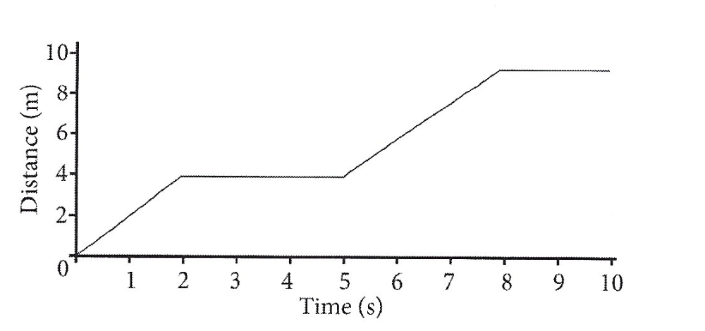

C
Velocity (m/s)
B

A

3 6 9 12 15 18 21 24 27 30
Time (sec)

- What is the car’s velocity at 18 seconds? (1 mark)
__________________________________________ 6 m/s________________________________________
- What is the car’s velocity at 30 seconds? (1 mark)
__________________________________________ 9m/s________________________________________

- What was the time when the car was travelling at 2 m/s? (1 mark)
_________________________________________3 seconds______________________________________
- Describe the car’s motion in Section B? (1 mark)

Car is moving at a constant speed, and has no acceleration (1)

- Describe the car’s motion in section A and state its acceleration. Show all working. (3 marks)

Car is speeding up and therefore accelerating. (1)
Gradient= rise/run = (y₂-y₁) / (x₂-x₁) = (4-0) / (6-0) 4/6 = 0.7 ms⁻²
- (1)

- Describe the car’s motion in section C and state its acceleration. Show all working. (3 marks)
___________
Car is speeding up and therefore accelerating. (1)
Gradient= rise/run = (y₂-y₁) / (x₂-x₁) = (9-4) / (24-15) = 5/9 = 0.6 ms⁻²
- (1)
- Compare the car’s motion in section A and C? (2 marks)
In section A the car is accelerating more than in section C (1) , by 0.1ms⁻² (1)

- A 30 ton semi-trailer is accelerating at 70 m/s/s and brakes suddenly to avoid a collision. What force must the brakes of the semi-trailer exert to stop it in 150 m? (4 marks)

F=ma (1) F= 30 000 x 70 = 210 000 N or 210 kN (1)

m= 30 ton= 30 000kg (1)
a= 70 m/s/s

- Find the net force applied in each of the following force diagrams. Do not forget to include the direction.
(5 marks)
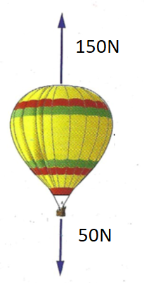
a)

100N Up (1 mark)

b)

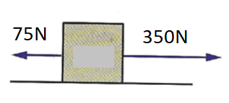

275N Right (1 mark)

c)
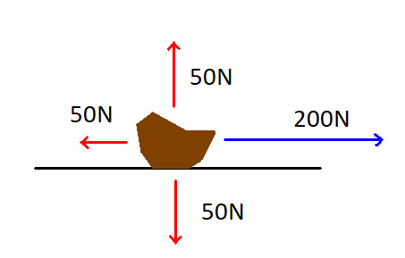

150N Right (1 mark)

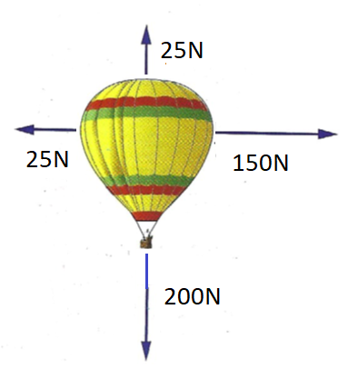
d)

125N Right (1 mark)
175N Down (1 mark)

Section 3: Extended Answer Question (5 marks)

1. Cars have many safety feature designs to protect the driver and its passengers.
a) Explain why a seatbelt is required in a car. (1 mark)
The seatbelt protects the driver from flying out of the window/or into the windshield (1 mark).
b) Which of Newton’s laws relate to this scenario? State the definition of this law. (3 marks)
Newton’s first law (1 mark).
It states that:
- An object at rest will remain this way unless it is acted upon by a force. (1 mark)
- An object that is moving will continue to move at the same speed and in the same direction unless an unbalanced force acts upon it. (1 mark)

c) Explain the importance of the airbag using newton’s law to explain. Use your answers from part a and b to assist you. (6 marks)

- When a car has a collision the person will continue in the direction the car was travelling before the collision (1 mark).
- Because the person will continue to move at the same speed and in the same direction unless acted upon by an unbalanced force (1 mark).
- This is stated by Newton’s first law of motion (1 mark).
- By having a seatbelt their body will remain in their seat (1 mark) due to the seatbelt acting as the unbalanced force (1 mark) rather than the person being projected forward into the windshield/or out the window by the collision (1 mark).

END OF TEST

